**Summer Reading**

**DHH kindergarten and First**

**Dr Seuss Books**

**Bob Books**

[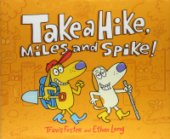](https://amzn.to/2H4xdHd)[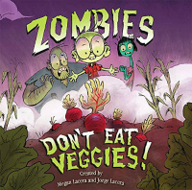](https://amzn.to/2VRnNqI)[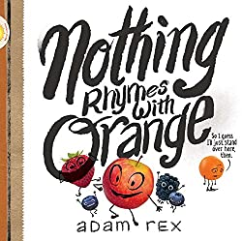](https://www.amazon.com/Nothing-Rhymes-Orange-Adam-Rex/dp/1452154430/ref=as_li_ss_il?keywords=Nothing+Rhymes+with+Orange&qid=1557159547&s=books&sr=1-2&linkCode=li3&tag=wdwdad-20&linkId=93e4fe80a0428389c681392c6663cc13&language=en_US)

 [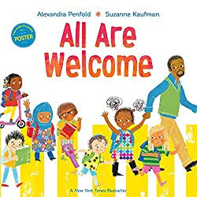](https://www.amazon.com/All-Are-Welcome-Alexandra-Penfold/dp/0525579648/ref=as_li_ss_il?ie=UTF8&linkCode=li3&tag=wdwdad-20&linkId=acf3682bf817333bd0b6b925fe181ebe) [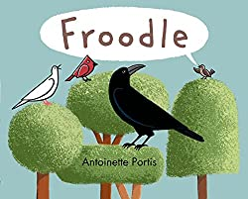](https://www.amazon.com/Froodle-Antoinette-Portis/dp/159643922X/ref=as_li_ss_il?ie=UTF8&linkCode=li3&tag=wdwdad-20&linkId=85a64430baffdec25437f9a7f239c4f6&language=en_US) 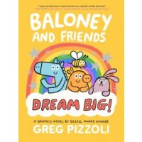

[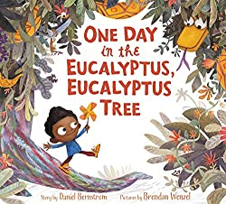](https://www.amazon.com/One-Day-Eucalyptus-Tree/dp/006235485X/ref=as_li_ss_il?ie=UTF8&linkCode=li3&tag=wdwdad-20&linkId=116fc2c85e7d15bd89b8214150ce0d21&language=en_US) [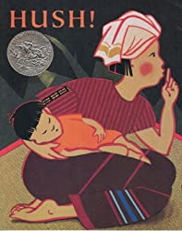](https://www.amazon.com/Hush-Thai-Lullaby-Minfong-Ho/dp/0531071669/ref=as_li_ss_il?crid=3O72BEMJGS3R4&keywords=hush+a+thai+lullaby&qid=1557159831&s=books&sprefix=hush,stripbooks,129&sr=1-1&linkCode=li3&tag=wdwdad-20&linkId=cc7c7d5ceea1999c4476f5d2bc8c0bbf&language=en_US) [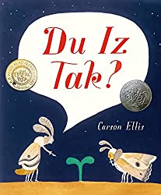](https://www.amazon.com/Du-Iz-Tak-Carson-Ellis/dp/0763665304/ref=as_li_ss_il?ie=UTF8&linkCode=li3&tag=wdwdad-20&linkId=2e55e099b98fda742fca56a6342227a9)

[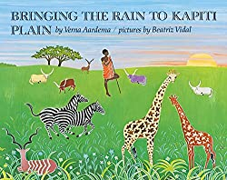](https://www.amazon.com/Bringing-Kapiti-Plain-Verna-Aardema/dp/0803708092/ref=as_li_ss_il?ie=UTF8&linkCode=li3&tag=wdwdad-20&linkId=237405efa7d1fb2471a589bd4572a9fe&language=en_US)

** 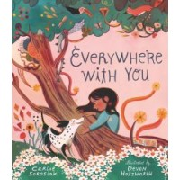

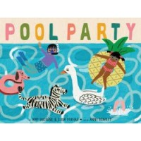

**DHH Summer Reading**

**for kindergarten and 1st**

**Books for Grade K (Kindergarten) – our recommendations**

* We Don't Eat Our Classmates by Ryan T. Higgins. ...
* Leave Me Alone! by Vera Brosgol. ...
* Hey, Water! ...
* I Don't Want to Be a Frog by Dev Petty. ...
* The Lion & the Mouse by Jerry Pinkney. ...
* Ten on a Twig by Lo Cole. ...
* Grumpy Monkey by Suzanne Lang. ...
* I Am Enough by Grace Byers.
* Mike Mulligan and His Steam Shovel by Virginia Burton. ...
* The Little Red Hen by Paul Daldone. ...
* The Story about Ping by Majorie Flack. ...
* Corduroy by Don Freeman. ...
* The Snowy Day by Ezra Jack Keats. ...
* Little Toot by Hardie Gramatky. ...
* Chika Chika Boom Boom! ...
* Make Way for Ducklings by Robert McCloskey.

**Books for Grade 1 – our recommendations**

* The Book Hog by Greg Pizzoli. ...
* The True Story of the Three Little Pigs by Jon Scieszka. ...
* There's an Alligator Under My Bed by Mercer Mayer. ...
* Freckle Juice by Judy Blume. ...
* The Boy Who Loved Words by Roni Schotter. ...
* There is a Bird on Your Head! ...
* Ramona the Pest by Beverly Cleary.
* Fly Guy by Tedd Arnold.
* See the Cat: Three Stories About a Dog by David LaRochelle.
* An Elephant & Piggie Biggie! by Mo Willems.
* See the Dog: Three Stories About a Cat by David LaRochelle.
* Donut Feed the Squirrels by Mika Song.

**DHH Summer Reading**

**for 2nd**

**Books for Grade 2 – our recommendations**

* Rosie Revere, Engineer by Andrea Beaty. ...
* Charlotte's Web by E B White. ...
* If I Built a Car by Chris Van Dusen. ...
* Once Upon a Cool Motorcycle Dude by Kevin O'Malley. ...
* Once Upon a Time by Niki Daly. ...
* Mr Popper's Penguins by Richard Atwater. ...
* Dear Max by Sally Grindley.

**2nd Grade Reading List Books**

* The House That Jack Built. Antonio Frasconi. ...
* Mr. Popper's Penguins (Paperback) ...
* Nate the Great (Paperback) Marjorie Weinman Sharmat. ...
* Freckle Juice (Paperback) ...
* Sarah, Plain and Tall (Sarah, Plain and Tall, #1) ...
* Owls in the Family (Paperback) ...
* Danny and the Dinosaur (Paperback) ...